Instructions for changing a scan head
- Turn off power to the scan heads (open L1-1S fuse or shutdown cabinet)
- When removing the heads from the scan frame, make sure you have the silver mounts below the scanners to prevent them from sliding off when unbolted
- Disconnect the threaded connector from the back, unbolt, then reverse to install the new head
- Power the system back on
- In the software, starting from the main menu, choose Setup Options
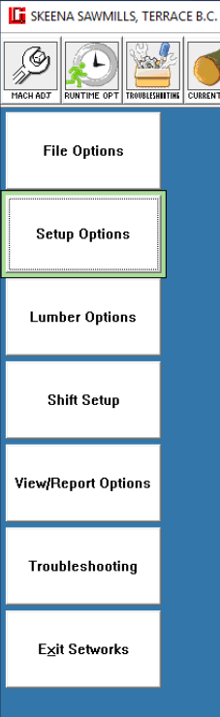
- Scanner Setup
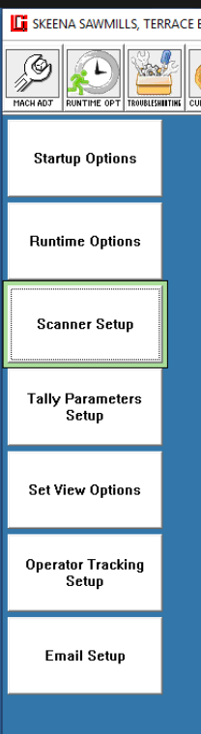
- Head S/N Assignment
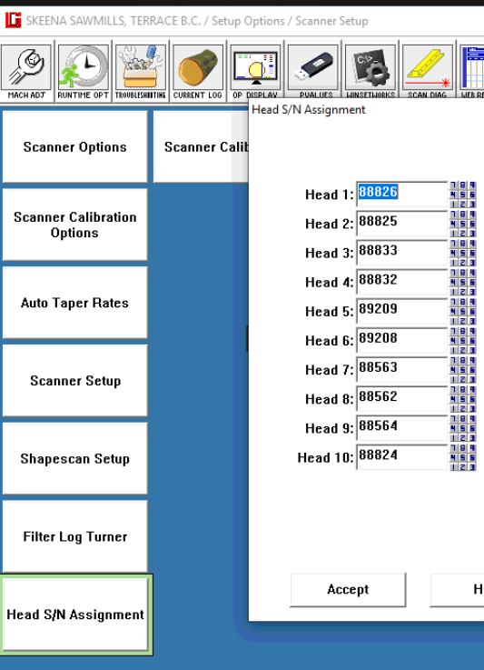
- The new scan head should have the serial number printed in large numbers and will likely be 6 digits starting with 1xxxxx. E.g. 111111, if you’re swapping head 10, change 88824 to 111111, then hit submit.
- Now you’ll need to close and reopen the software.
- When you swap a scan head, it’s best to calibrate right away.

